Serkan Berk Bilgiç – 71571 - [sbilgic19@ku.edu.tr](mailto:sbilgic19@ku.edu.tr)

* There are 2 types of request is allowed in my protocol. First one, in below fetches all the NFTs and lists them.

**sbbp -m/GET -r/NFTServer -v/1.0**

* The other one is to fetch information fort he specific NFTs by ids. Here I designed in such a way that single or multiple ids can be given simultaneously and the result returned from the NFTMultithreadedServer will show the information such as **name**, **asset_platform_id**, and **price** for all the given ids.

**sbbp -m/GET -r/NFTServer -v/1.0 -i/{nft_id1, nft_id2, nft_id3, …}**

As an example fort he second case I can give the following request and you can see the result returned.

**sbbp -m/GET -r/NFTServer -v/1.0 -i/{ethlings, squiggly}**

**Note: -m represents method type, -r represents resource type, -v represents version and I did not extended but for generality I wanted to design this way and if you do not provide any of this 3 with the exact -m|-r|-v/ notation or say you request -v/1.1 or -r/CoinSomething it will give an error. In the below you can find examples for each of them.**

**Client Side Cases:**

**Some Problematic Cases :** For now only GET method exist and the only resource is NFTServer and only version is 1.0 and -m|-r|-v/ notation must be used.In the below you can see examples of different wrong request such as not providing resource

**1:** Adding noise to the any part of the request for example sbbps or -v123 or adding .. at the end all will result in Unexpected Bad Request with code 605. I made up codes this is the most general error code.

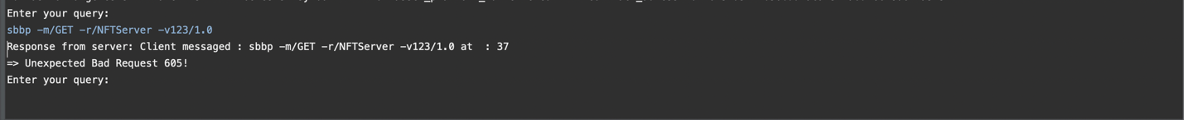

**2:** Not providing protocol_name (sbbp), resource, method or version or providing unavailable for any of them will give different error codes. For protocol name which is exactly sbbp it is 600, for method type(only GET method is avaiable) 601, for resource(only NFTServer available) 602, for version(only 1.0 is available) 603. You can see examples for each of them in the below screenshot.

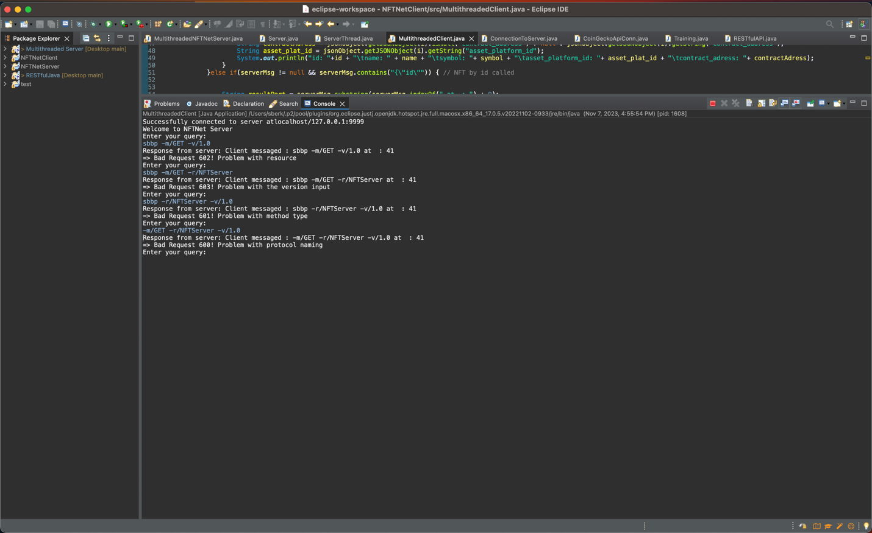

**3:** If correct request is made and -i flag is not provided it will list all the results.

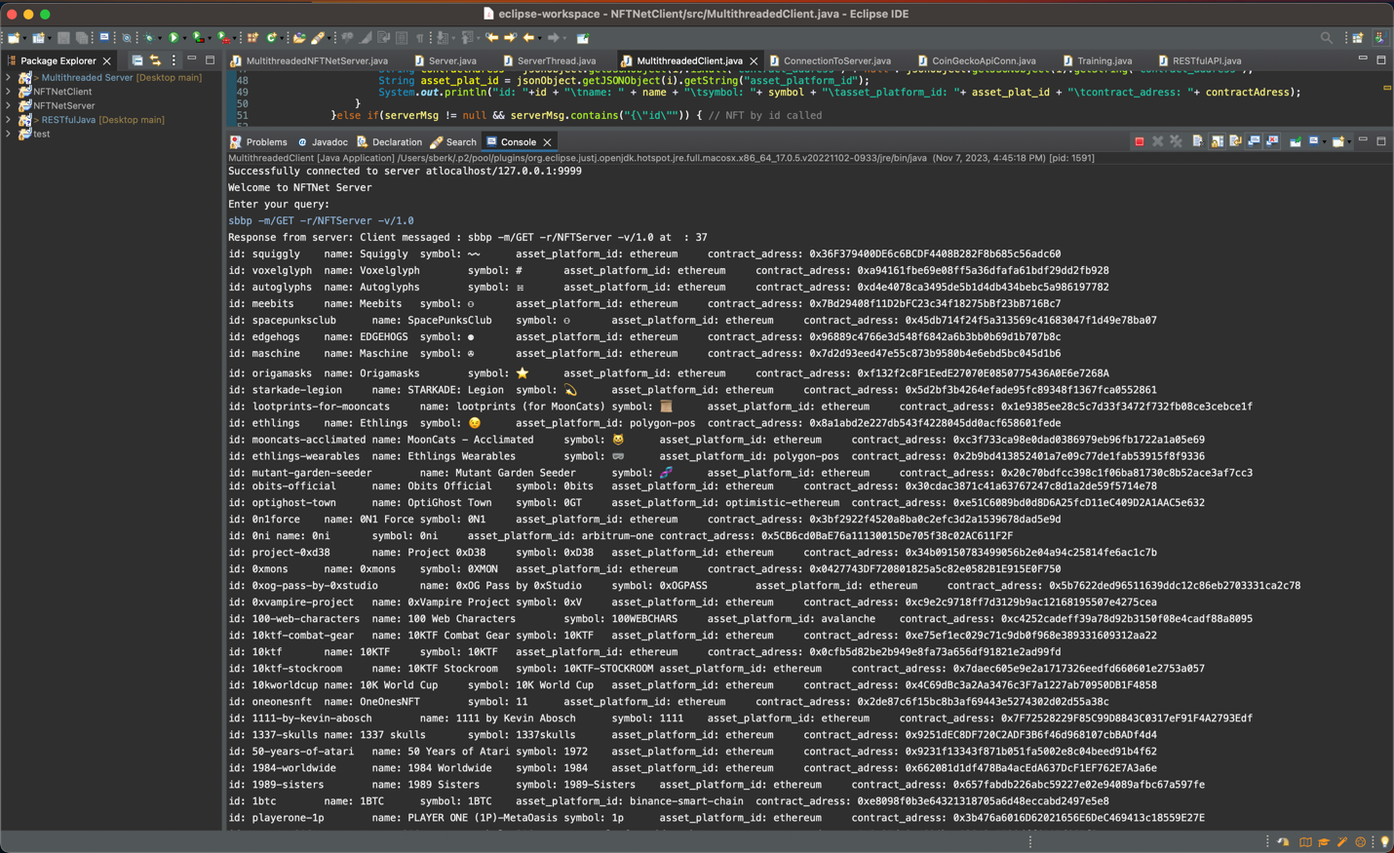

**4:** If multiple ids provided the result will be returned for each

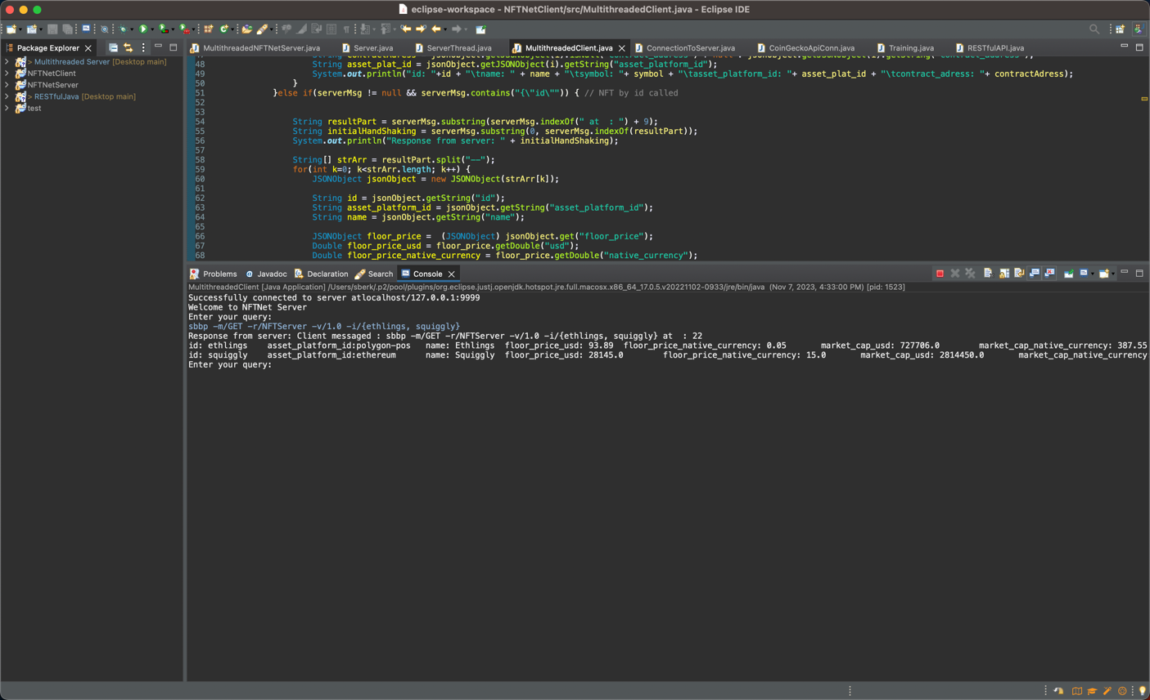

**5-** If single id provided the result will be returned for each

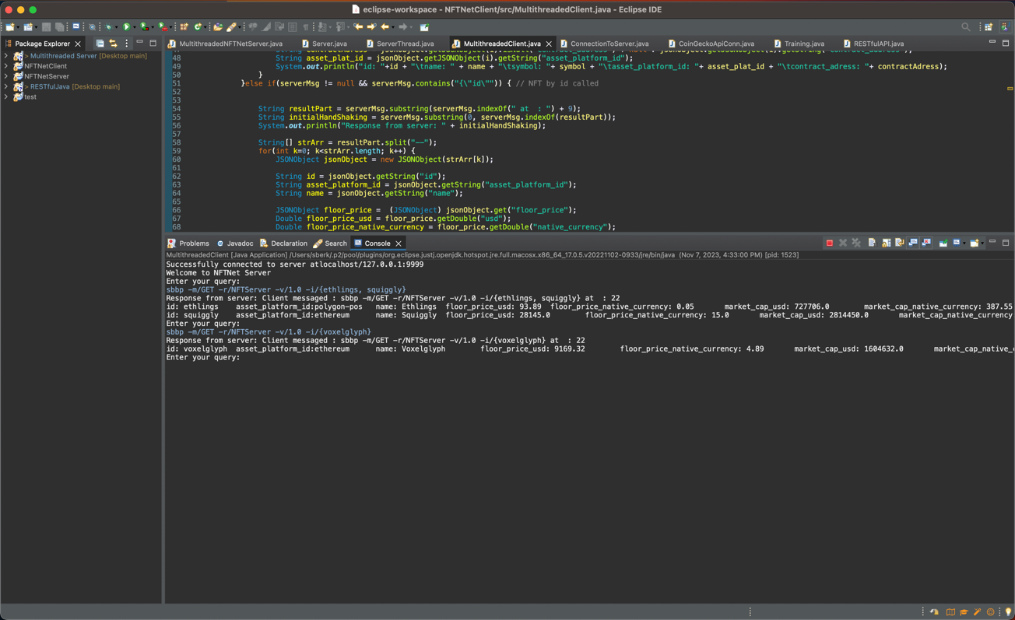

**6-** If any of the id is incorrect it will return an error which says **“Something unexpected happened. Please check your NFT ids”.**

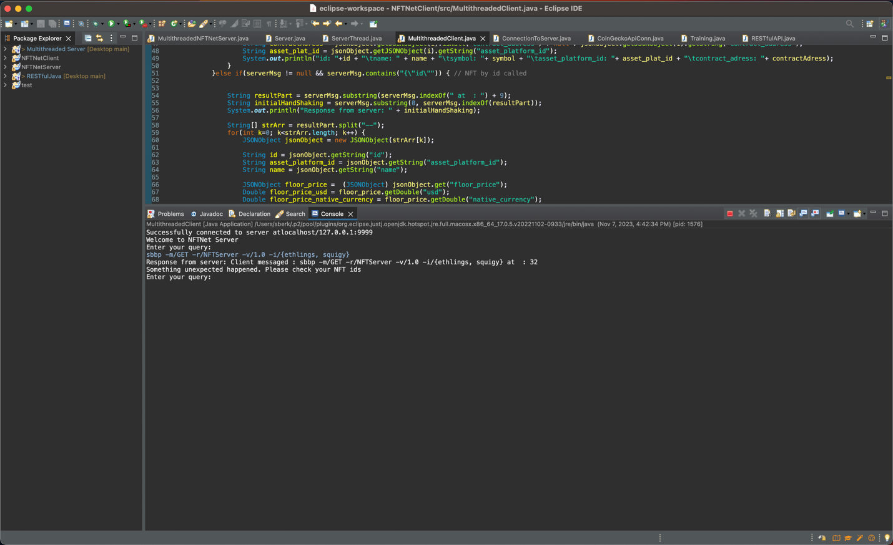

**7-** If no id is provided but -i flag is given it returns an error which says **“Something unexpected happened. Please check your NFT ids”.**

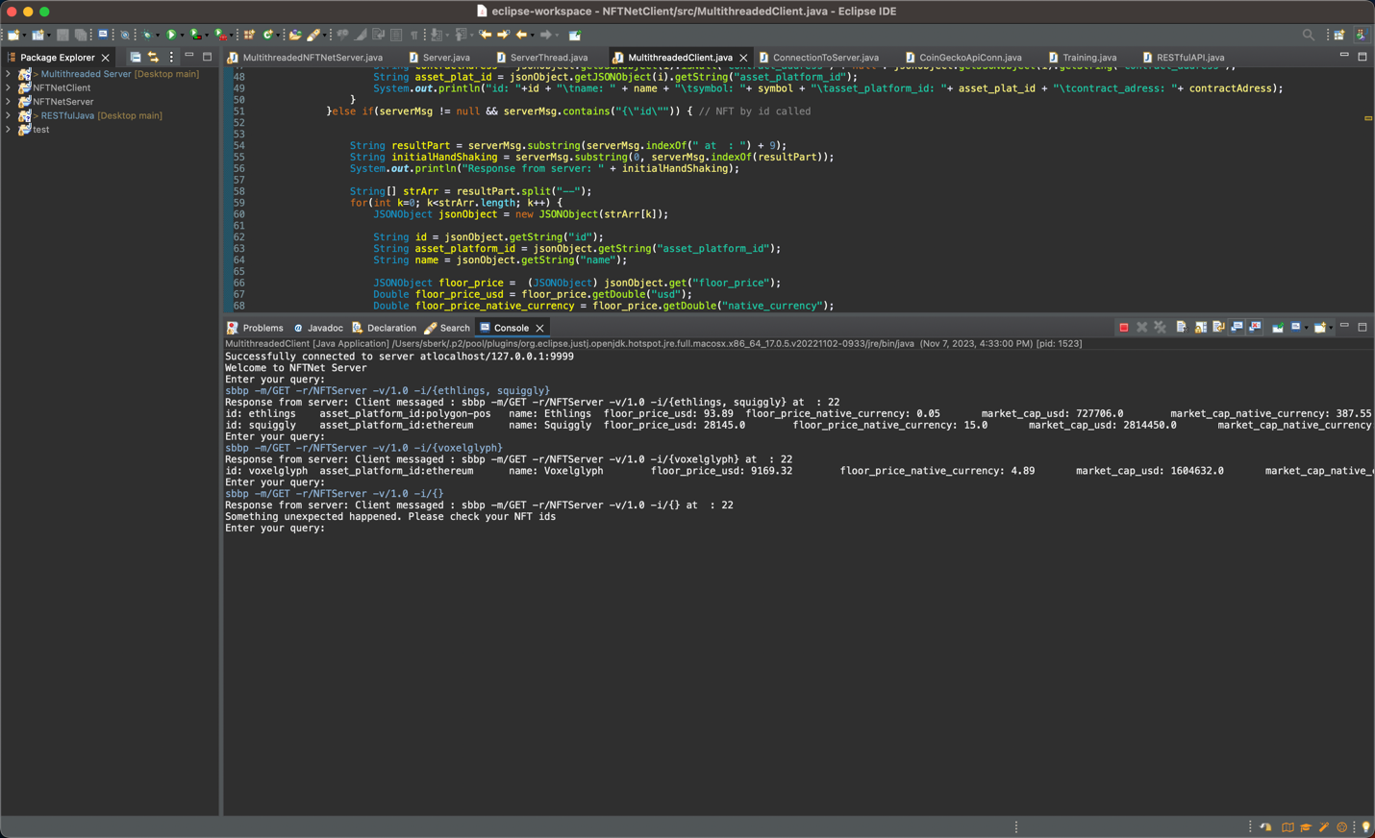

**8:** If for 30 seconds no query is provided by client the server will close the Socket and prints “Read Timeout”. After this point even if in the client terminal there is no error, when client tries to give an input it gives an error.

Client Before Giving Input

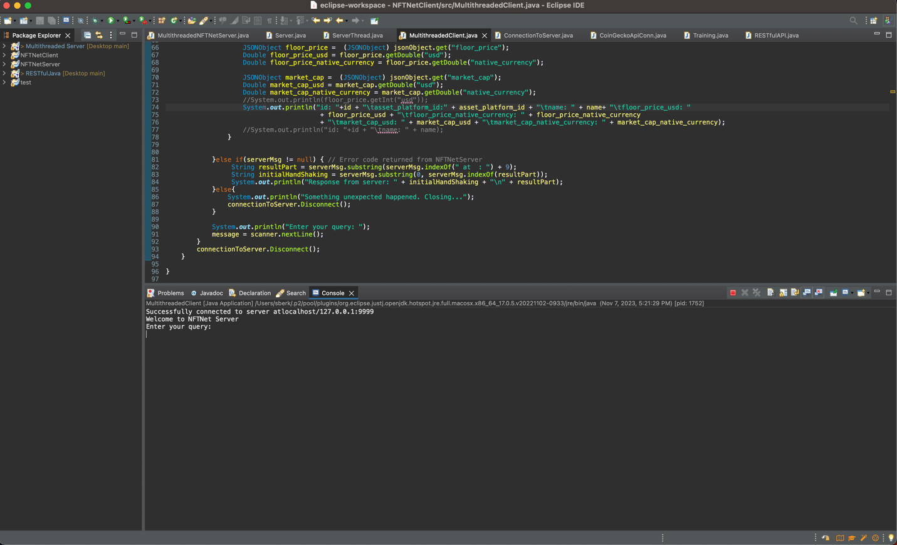

**9:** If client waits more than 10 seconds without providing any requests Socket will be closed for that specific client.

Server:

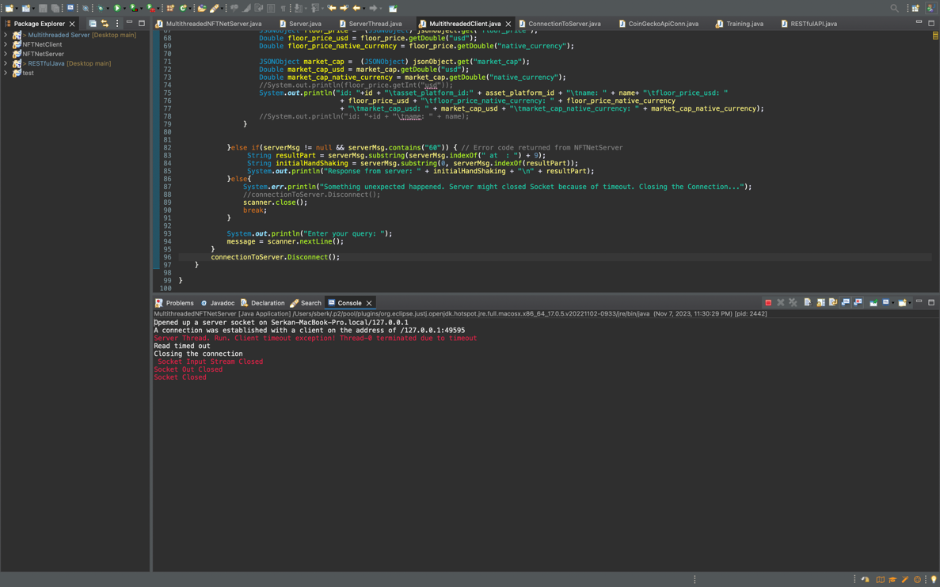

Client:

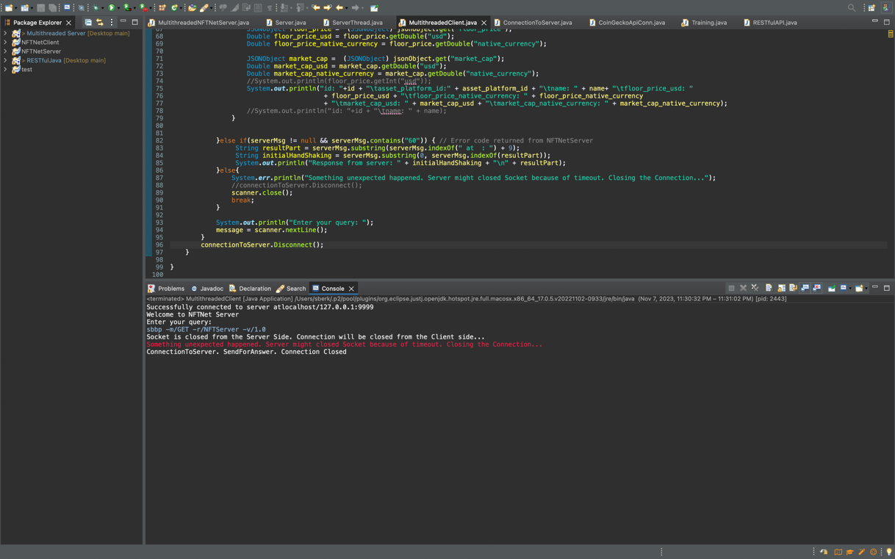

**Server Side Cases:**

**1:** Multiple client can connect at the same time. Correct requests will be handled and request coming from each client printed to the Server’s console. Results can be seen in Client Side below you can see the screenshot for appropriate request from client and the Server’s response to it via different terminals.

Server Terminal:

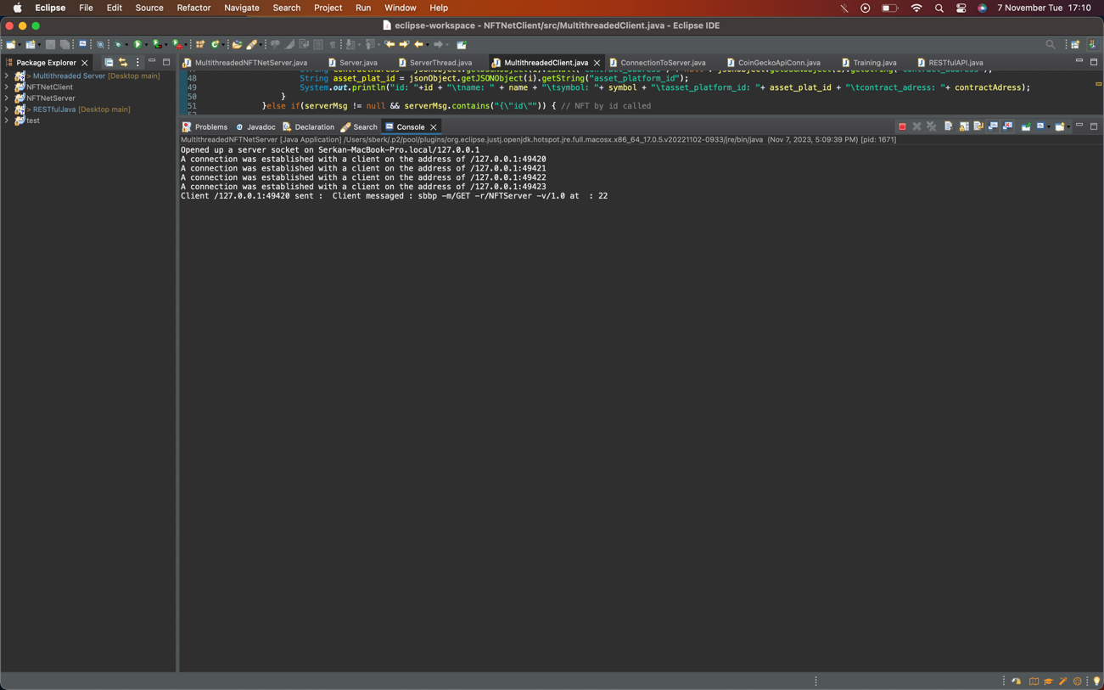

Client Terminal:

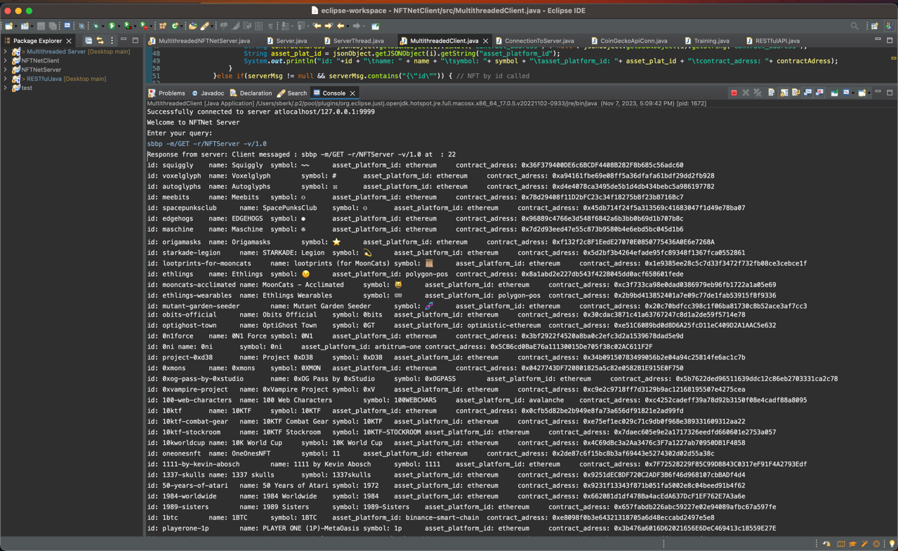

**2:** For inappropriate request Server sends a message to the Client. In the below example you can see that client sends request with -v/1.1 but only avaible version is 1.0. So as can be seen from the screenshots the client terminal prints an error.

Server Terminal:

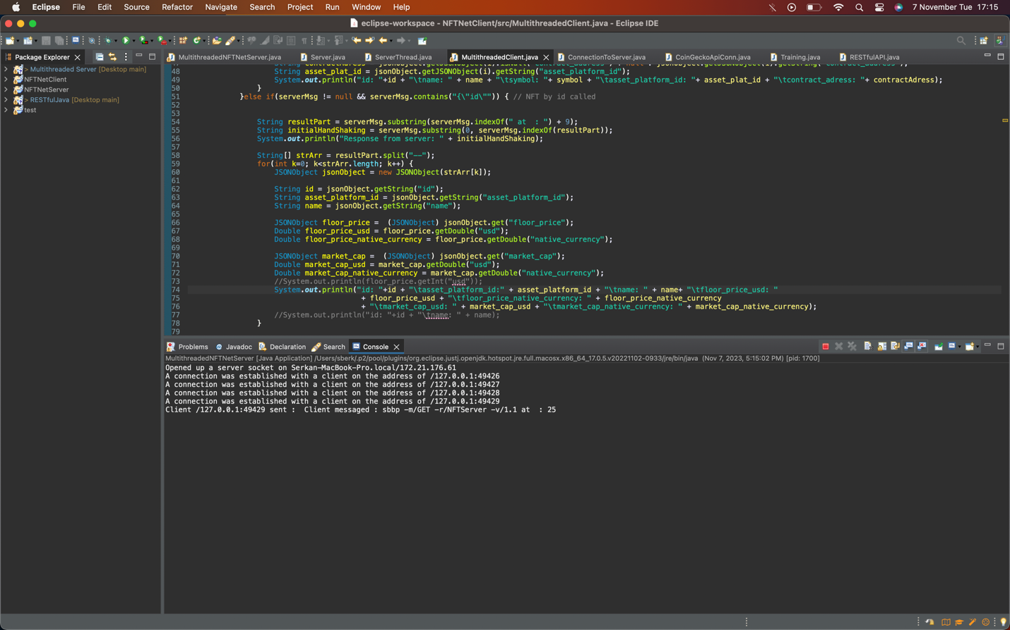

Client Terminal:

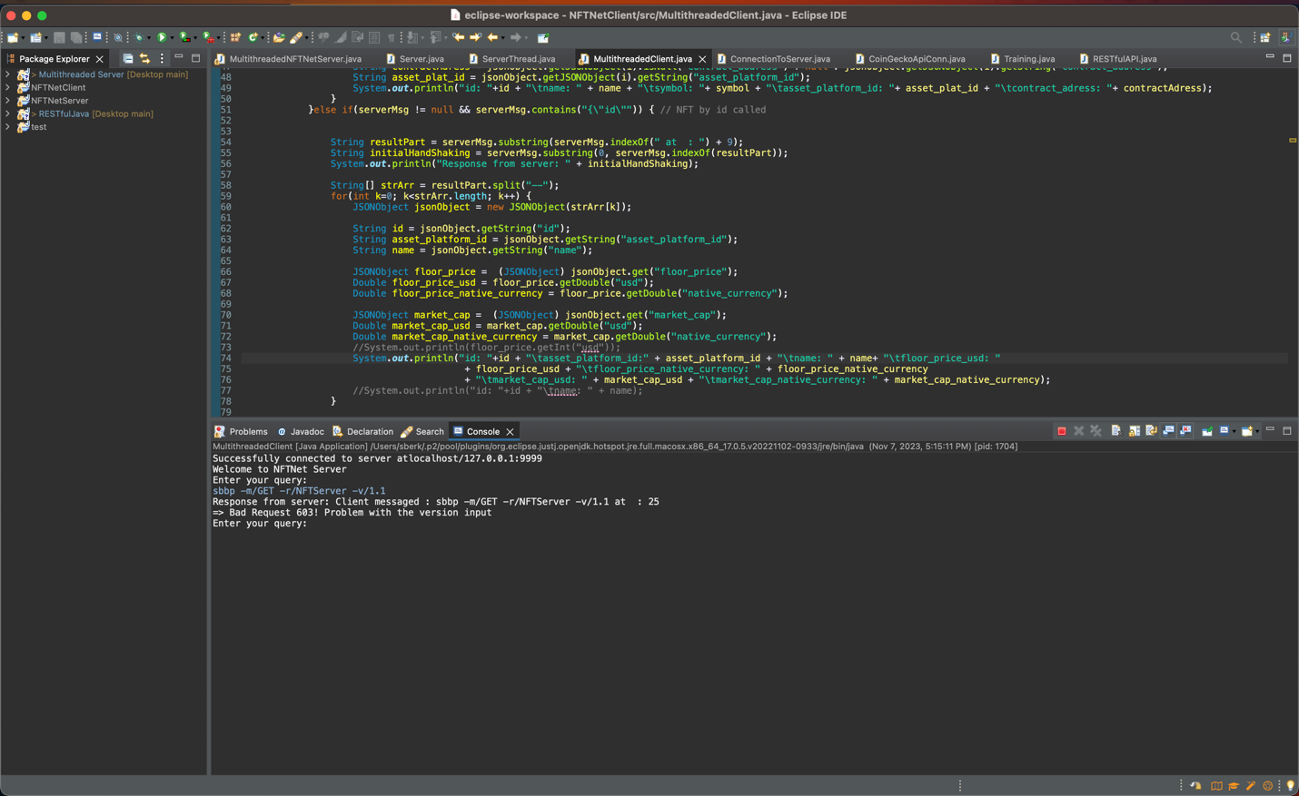

**3:** If client waits more than 10 seconds without providing any requests Socket will be closed for that specific client.

Server:

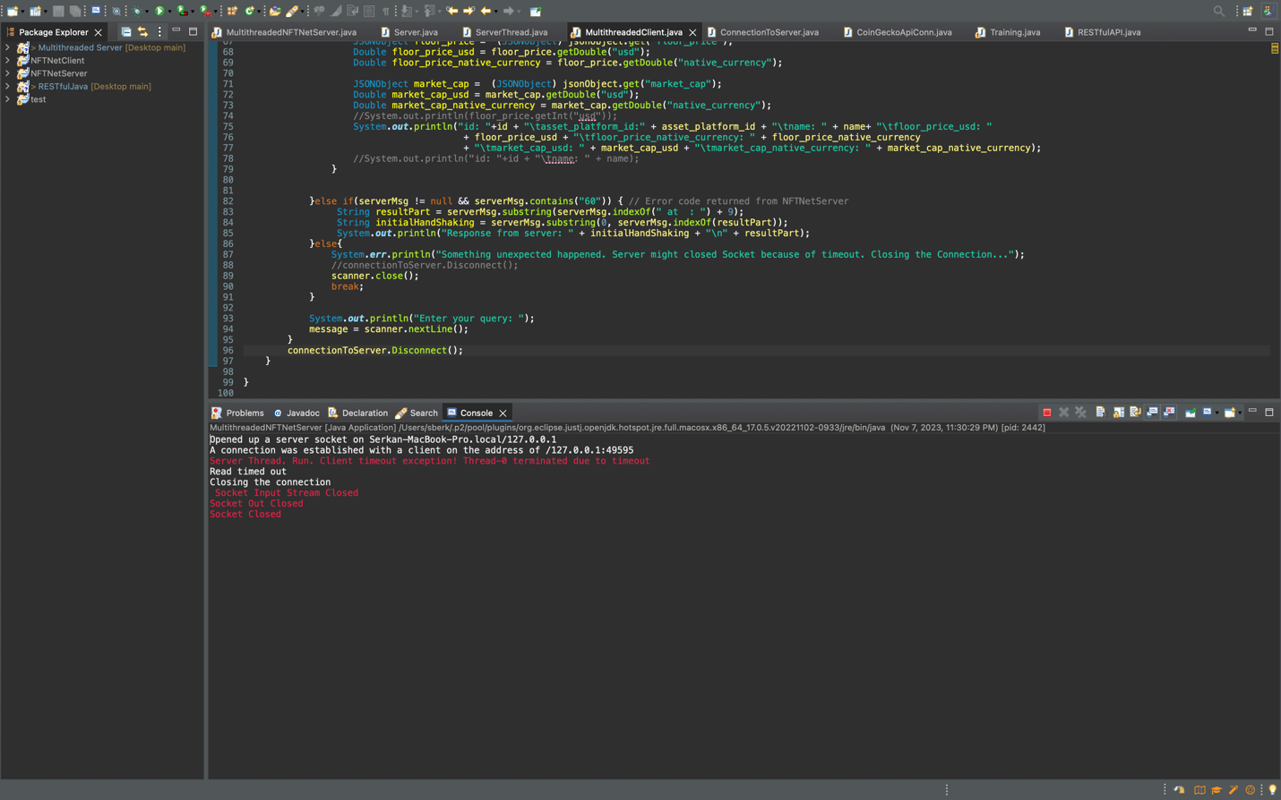

Client:

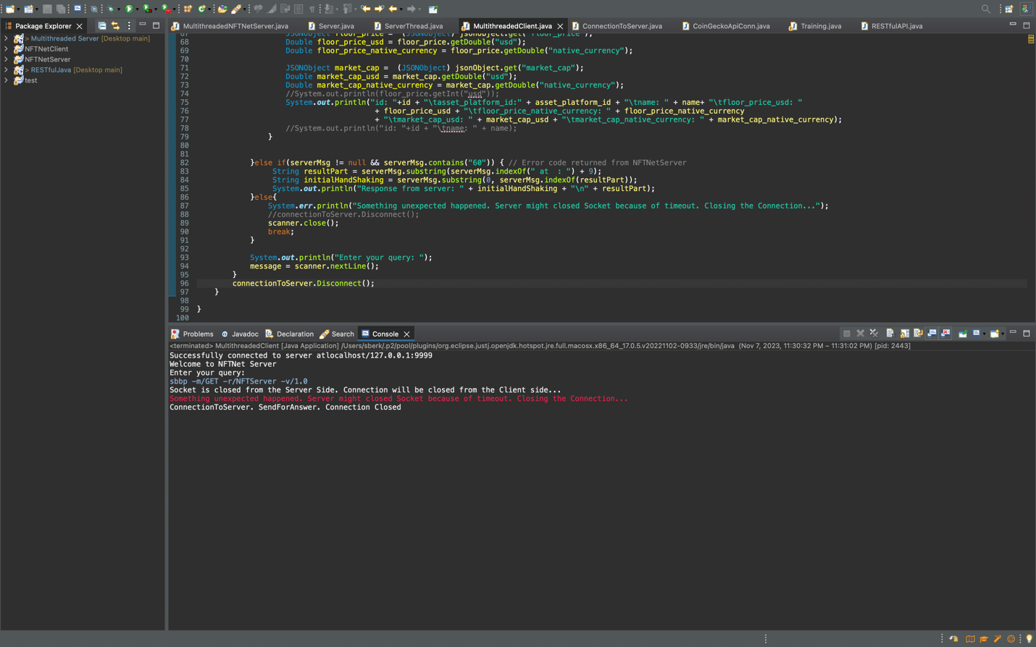

**Screenshots from Codes:**

